PROJECT DESIGN PHASE-II TECHNOLOGY STACK (ARCHITECTURE & STACK)

|  |  |
| --- | --- |
| **Date** | **28 October 2022** |
| **Team ID** | **PNT2022TMID41907** |
| **Project Name** | **Personal Assistance for Seniors who are Self- Reliant** |
| **Maximum Marks** | **4 Marks** |

Technical Architecture:

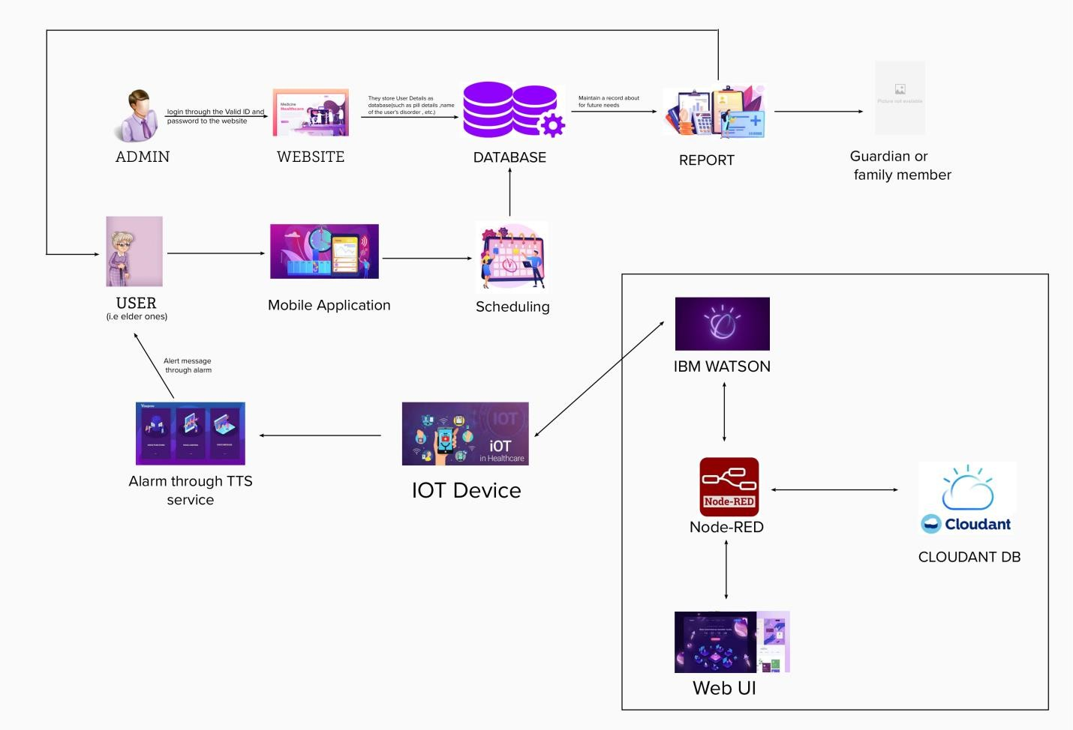

**TABLE-1 : COMPONENTS & TECHNOLOGIES:**

|  |  |  |  |
| --- | --- | --- | --- |
| **S.No** | **Component** | **Description** | **Technology** |
| 1. | User Interface | How user interacts with application | HTML, CSS,  JavaScript / Angular Js / React Js. |
| 2. | Application Logic-1 | Logic for a process in the application | Python |
| 3. | Application Logic-2 | Logic for a process in the application | TTS service |
| 4. | Application Logic-3 | Logic for a process in the application | IBM Watson |
| 5. | Database | Data Type, Configurations etc. | MySQL |
| 6. | Cloud Database | Database Service on Cloud | IBM Cloudant |
| 7. | File Storage | File storage requirements | IBM Block Storage or Other Storage Service or Local Filesystem |
| 8. | External API-1 | Purpose of External API used in the application | Medical Report of the patient |
| 9. | Infrastructure (Server  / Cloud) | Application Deployment on Local System / Cloud  Local Server Configuration: Cloud Server Configuration  : | Local, Cloud Foundry, Kubernetes, etc. |

TABLE-2: APPLICATION CHARACTERISTICS:

|  |  |  |  |
| --- | --- | --- | --- |
| **S.No** | **Characteristics** | **Description** | **Technology** |
| 1. | Open-Source Frameworks | List the open-source frameworks used | Technology of Opensource |

|  |  |  |  |
| --- | --- | --- | --- |
| **S.No** | **Characteristics** | **Description** | **Technology** |
|  |  |  | framework |
| 2. | Security Implementations | List all the security / access controls implemented, use of firewalls etc. | Encryptions, IAM Controls, OWASP etc. |
| 3. | Scalable Architecture | Justify the scalability of architecture (3 – tier, Micro- services) | Technology used |
| 4. | Availability | Justify the availability of application (e.g. use of load balancers, distributed servers etc.) | Technology used |
| 5. | Performance | Design consideration for the performance of the application (number of requests per sec, use of Cache, use of CDN’s) etc. | Technology used |